Java使用SOAP获取webservice实例解析

- webservice提供方： http://www.webxml.com.cn/zh_cn/index.aspx
- 下面我们以 获取天气预报 为例。
参数截图如下图：
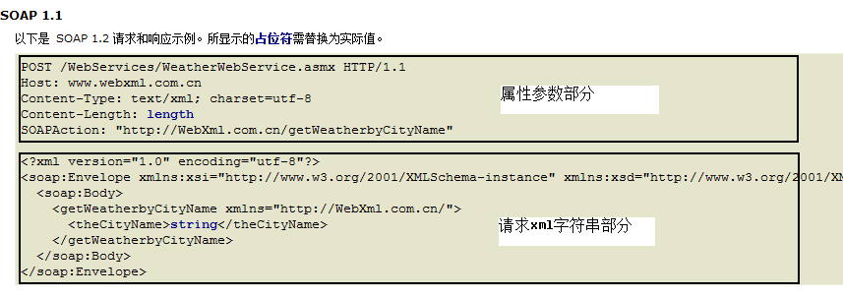
[http://www.webxml.com.cn/WebServices/WeatherWebService.asmx?op=getWeatherbyCityName] 点击前面的网址，查看对应参数信息。

- Java程序

程序需要引用:
import java.io.*;
import java.net.*;
import java.util.Vector;
String urlString = "http://www.webxml.com.cn/webservices/qqOnlineWebService.asmx";
String xmlFile = "QQOnlineService.XML";
String soapActionString = "http://WebXml.com.cn/qqCheckOnline";
URL url = new URL(urlString);
HttpURLConnection httpConn = (HttpURLConnection) url.openConnection();;
File fileToSend=new File(xmlFile);
byte[] buf=new byte[(int)fileToSend.length()];
new FileInputStream(xmlFile).read(buf);
httpConn.setRequestProperty( "Content-Length",String.valueOf( buf.length ) );
httpConn.setRequestProperty("Content-Type","text/xml; charset=utf-8");
httpConn.setRequestProperty("soapActionString",soapActionString);
httpConn.setRequestMethod( "POST" );
httpConn.setDoOutput(true);
httpConn.setDoInput(true);
OutputStream out = httpConn.getOutputStream();
out.write( buf );
out.close();
InputStreamReader isr = new InputStreamReader(httpConn.getInputStream(),"utf-8");
BufferedReader in = new BufferedReader(isr);
String inputLine;
BufferedWriter bw=new BufferedWriter(new OutputStreamWriter(new FileOutputStream("result.xml")));
while ((inputLine = in.readLine()) != null){
System.out.println(inputLine);
bw.write(inputLine);
bw.newLine();
}
bw.close();
in.close();
说明：QQOnlineService.XML文件的内容就是上面截图中的请求xml字符串部分。

以上由网友提供,QQ: 279806210

